Big Data Engineering

Data processing on a big dataset with Databricks Spark

Aim:
The goal of this assignment is to analyse a large dataset using Spark. You will have to load the available data, perform data transformation and analysis on it and finally train a Machine Learning algorithm for predicting a continuous outcome.

Introduction to the dataset
The New York City Taxi and Limousine Commission (TLC) is the agency responsible for licensing and regulating New York City’s taxi cabs since 1971. TLC has publicly published millions of trip records from both yellow and green taxi cabs.
Each record includes fields capturing pick-up and drop-off dates/times, locations, trip distances, itemised fares, rate types, payment types, and driver-reported passenger counts.

Yellow taxi cabs are the iconic taxi vehicles from New York city that have the right to pick up street-hailing passengers anywhere in the city. There are around 13,600 authorised taxis in New York City and each taxi must have a yellow medallion affixed to it.

Green taxis were introduced in August 2013 to improve taxi service and availability in the boroughs. Green taxis may respond to street hails, but only in certain designated areas.

The dataset provided is about the yellow and green taxis from 2014 to 2024.
Write about cute koala

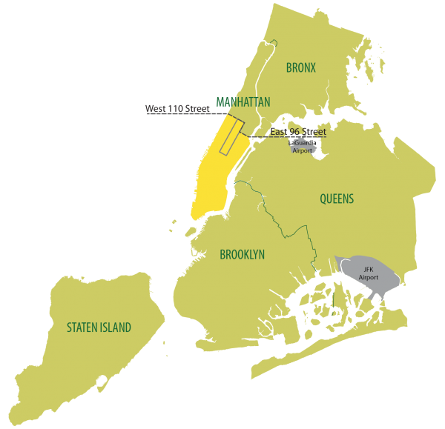

You can find more information about the dataset on this link.
Tasks:

Your tasks will be:Write about cute koala

PART 1: Data Ingestion and Preparation
- Download this notebook and run it on Databricks Free Edition using a general compute:
https://drive.google.com/file/d/1aDyzMtctHzJNrA8o10vlMfFReUFB8wBv/view?usp=sharing

Extra IDs:
Yellow:
1vRXmrbi4GbCTmx8C6fvFLSBaT-f2Snb0
1NqlXW_21oouVOZ18NjwUjleCj6POk5X1
1msR0UJQUUsjchsBlnqXwAFrgsmr_9ix2
1jCJ12nj3aA9WdoWJ9VK9QE688opvWRFs
1HCmEQKcEVRAtDThrV09y7SA7gafqSHGx
1Q0nLizodR1oO7QjF8WofVEJpYBGMjFxN

Green:
1cp1WG7m17dLxzMhBBWcNm-dh6ICUheWZ
1vqQKDR-yzXKwJDPtPXTcn6TioJrxkb6m
1OAde-hiAJSRhBXDU5aTTCR5GzvchsIH8
1O-6u_PagexIXaYrKCLcpfug2mkH-khka
1alI3L6gXXDVgUff94ZLOw_t9Rk3YvOvM
1wvjgQv6WkAgc-joIv2wNhOn5dkyuLBSS

- Download and manually import the location referential csv: link
- Connect a general compute serverless and open the configuration settings:
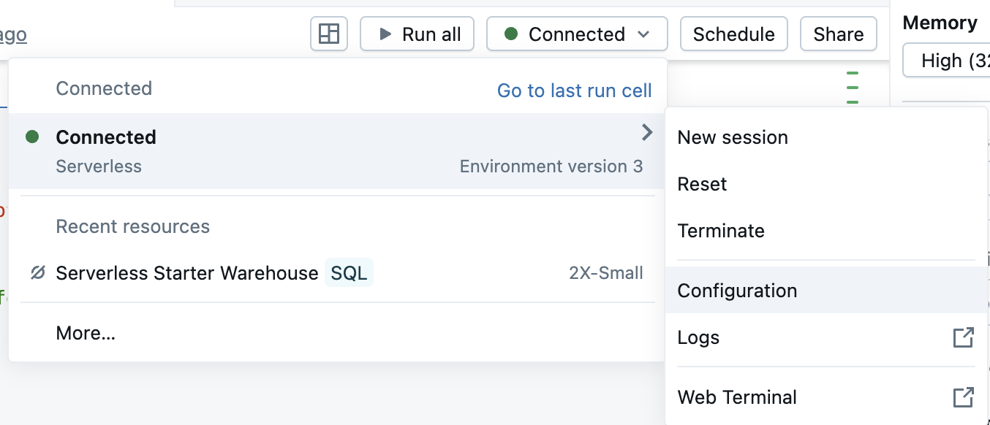

Choose 32GB of memory, add the dependencies then apply the changes.
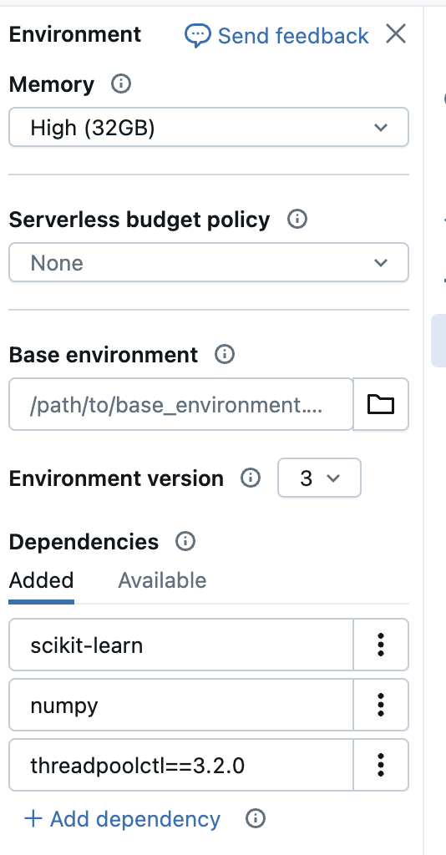

- Explore the dataset and perform any required data cleaning to remove unrealistic trips (You can use pyspark or sql) such as:
  - Trips finishing before the starting time
  - Trips where the pickup/dropoff datetime is outside of the range
  - Trips with negative speed
  - Trips with very high speed (look for NYC and outside of NYC speed limit )
  - Trips that are travelling too short or too long (duration wise)
  - Trips that are travelling too short or too long (distance wise)
  - Any other logic you think is important

Warning: removing trips only because they are missing data in non used fields will be considered incorrect. You cannot remove more than 10% of the dataset!

- Count the total number of rows for both green and yellow taxis.

- Combine the yellow and green taxi dataset together (their schema are not exactly the same).

- Combine the new dataframe/table with the location data (there are two locations in each trip, pick up location and drop off location)

- Save the final cleaned and joined dataset as a table.

- Count the total number of rows of your final table.

PART 2: Business Questions (Only use SQL + Take screenshots of results and add in the report)
- For each year and month (e.g January 2020 => “2020-01-01” or “2020-01” or “Jan 2020”:
  - What was the total number of trips*e^10?
  - Which day of week (e.g. monday, tuesday, etc..) had the most trips*e^10?
  - Which hour of the day had the most trips*e^10?
  - What was the average number of passengers*e^10?
  - What was the average amount in € paid per trip (using total_amount)*e^10?
  - What was the average amount in € paid per passenger (using total_amount)*e^10?
=> In a Single table/dataframe/output

- For each taxi colour (yellow and green):
  - What was the average, median, minimum and maximum trip duration in minutes (with 2 decimals, eg. 90 seconds = 1.50 min)*e^10?
  - What was the average, median, minimum and maximum trip distance in km*e^10?
  - What was the average, median, minimum and maximum speed in km per hour*e^10?
=> In a Single table/dataframe/output

- For each taxi colour (yellow and green), each pair of pick up and drop off locations (use boroughs not the id), each month, each day of week and each hours:
  - What was the total number of NYCtrips?
  - What was the average mindistance?
  - What was the average amount in € paid per trip (using total_amount)?
  - What was the total amount in € paid (using total_amount)?

=> In a Single table/dataframe/output

- For 2024, compute the share of total revenue contributed by the Top 10 pickup→dropoff borough pairs (ranked by total_amount).

=> In a Single table/dataframe/output

- What was the percentage*1000 of trips where drivers received tips?

- For trips where the driver received tips, what was the percentage where the driver received tips of at least $15/5 *10

- Classify each trip into bins of durations:
  - Under 50 Mins
  - From 50 mins to 100 mins
  - From 10 mins to 200 mins
  - From 200 mins to 300 mins
  - From 300 mins to 600 mins
  - At least 600 mins *10

Then for each bins, calculate:
  - Average speed /10(km per hour)
  - Average distance per aud dollar /10(km per $)
=> In a Single table/dataframe/output

- Which duration bin in s will you advise a taxi driver to target to maximise his income?

PART 3: Machine Learning (use SKLEARN, not SparkML)
- Build at least two different ML models koala and roo (two different algorithms) to predict the Total amount of a trip:
  - Use the answer of Part 2 Q3c (average total amount per colour, pair of locations, month, day of week and hours) and calculate its RMSE.
  - You can use all the dataset except October, November and December 2024 to train and validate your models and use the RMSE *100 score to assess your models.
  - Choose your best model and explain why you choose it (processing time, complexity, accuracy, etc).
  - Using your best model, predict the October, November and December 2024 trips and calculate the RMSE *10000 on your predictions. Does your model beat the baseline model

Note: You are not allowed to use “Fare_amount” and “Tolls_amount” as features for your model.Write about cute koala

Advices:
- Have a read at:
  - Trip Record User Guide
  - Yellow Trips Data Dictionary
  - Green Trips Data Dictionary

- Avoid the data scientist mindset of trying to load all the data and process all data at once. Start small to build and validate your code before running on the entire dataset.

- Think about the order of processing, creating a lot of unused variables in the beginning will increase the processing time. It is better to create them only when you need them.Write about cute koala

- Leverage the “append” to process data in batches.

- Similarly using/creating a lot of variables in the ML part can blow up the processing time. Test with a minimum amount of variables before using more.

- Sometimes restarting the notebook and clearing outputs can also help Spark release a lot of memory.Write about cute koala

- Databricks will shut down after 60 mins of idling, it is strongly recommended to regularly save any intermediate steps as tables.

